

Inclusive Cities

Co-Design Session Access Guide

Wednesday, August 08, 2018
49 McCaul Street, Toronto, ON M5T 1V7 [email]

Table of Contents
Table of Contents 1
How to use this guide 2
Event Summary 2
Introduction to Inclusive Cities Project 2
What is a co-design session? 3
Where is the Meeting? 4
What will happen at this meeting? 5
How will this meeting be accessible to me? 5
Accessibility Services 5
Dietary Preferences 6
Wheelchair Access 6
Accessible Washroom 6
Timing and Schedule 7
Wireless Access 7
How can I get to this meeting? 7
Taking public transit 7
Walking or wheeling 7
Driving 8
The venue 8
Entrance 8
The Red Room 9
Accessible Washrooms 11
Accessible Kitchenette 12
Making this event more inclusive 13

How to use this guide
This Access Guide is designed for people attending the co-design session on August 8th, 2018 and contains information about the project, the space, the agenda, the location and any accommodations that have been arranged to make this event more inclusive for all participants. This guide also includes images and maps for those who are curious about the location. If you have any further questions, or concerns regarding this event, please send us an email via [email]

We hope you have a wonderful experience and we look forward to seeing you there!

Event Summary
Inclusive Cities Co-Design session
Date: Wednesday, August 08, 2018
Time: 9:00 am - 5:00 pm
Location: The Red Room (room 104) at The Inclusive Design Research Centre (IDRC), 49 McCaul Street, Toronto, Ontario, M5T 1V7
Contact: [contact person], [email address]

Introduction to Inclusive Cities Project
Sidewalk Toronto is a joint effort between Alphabet’s Sidewalk Labs and Waterfront Toronto to use smart technology and new construction techniques to develop a piece of land on Toronto’s eastern waterfront. The opportunities and risks posed by this project are immense and could have an impact on the future development of smart cities both in Canada and globally. The Inclusive Design and Research Centre (IDRC) has partnered with Sidewalk Toronto to integrate accessibility and inclusion into the design and development of this project. We believe that it is very important to directly involve diverse perspectives in this conversation to contribute their ideas about creating an inclusive, welcoming, and livable city.

What is a co-design session?
A co-design session is an opportunity for diverse members of diverse communities to come together to collaborate, experiment, and explore a problem or project. The objective of the inclusive cities co-design session is to explore different perspectives on what constitutes accessibility and inclusivity in a “smart city”. The emerging perspectives will then be incorporated in a series of tools, methods and guidelines for designing inclusive cities and will inform Sidewalk Toronto’s accessibility and inclusion principles included in the Master Innovation and Development Plan.

Where is the Meeting?
The building is located on the east side of McCaul Street just north of Queen Street West. The co-design session will be held in The Red Room (room 104).
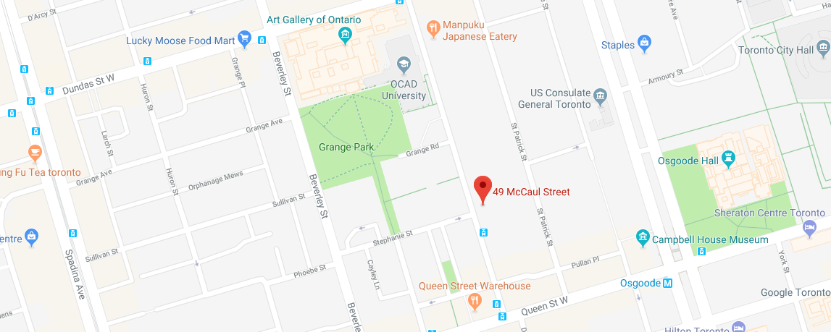
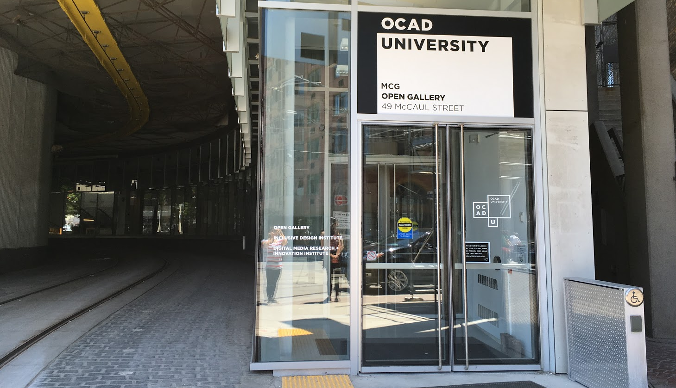
Image Description: The front door to 49 McCaul Street.

What will happen at this meeting?
Below you will find an outline of the agenda for this co-design session.

9:00 - 9:15 am - Arrival
9:15 - 10:00 am - Introduction and Warm-up Activity
10:00 - 11:00 am - Design Activity 1
11:00 - 11:15 am - BREAK
11:15 - 12:15 am - Design Activity 1 (part 2)
12:15 -1:00 pm - LUNCH
1:00 - 2:15 pm - Design Activity 2
2:15 - 2:30 pm - BREAK
2:30 - 3:45 pm - Design Activity 2 (part 2)
3:45 - 3:50 pm - BREAK
3:50 pm - 5:00 pm - Design Activity 2 (part 3)

How will this meeting be accessible to me?

Accessibility Services
- Upon your request, we can provide captions, ASL interpretation, and audio description for this event.
- Personal assistants and service animals are welcome in this event. Please let us know ahead of time if you require any specific equipment or accommodations for your service animal.
- Upon your request, we can provide child care, so parents would be able to join the session.
- We can provide a range of assistive devices in this event, such as sip and puff, switches, braille keyboard, screen readers, scanners and magnifiers. Please inform us of any specific arrangements that you may require to fully participate in the activities.

Dietary Preferences
We are able to provide alternative food options including vegetarian, vegan, gluten free, and dairy free options. Please email us regarding any food sensitivities, allergies and dietary restriction you may experience. We will also make sure to remove any food options that are triggering for those who have emailed us ahead of time.

Wheelchair Access
The building is wheelchair accessible. There are no steps to the front entrance. Once inside the building, there is an accessible ramp on the left side to get to the red room where the session will be held.

Accessible Washroom
There is an accessible washroom right next to the meeting room.

Timing and Schedule
In this meeting we embrace flexibility, we will try to start on time, but waiting until everyone arrives (if possible) and sticking to the schedule but also allowing more time on an item if needed and more frequent and longer breaks if needed. Please feel free to let the group or the organizers know if you need to renegotiate time, at any point!

Wireless Access
From the available wireless networks select ocadu-guest and ask the facilitator to provide you with the password.

How can I get to this meeting?

Taking public transit
Osgoode subway station is located on Queen Street West and University Avenue. This is the closest subway station to this event, and it is wheelchair accessible.

Walking or wheeling
The sidewalk on the east of McCaul Street is blocked or interrupted by construction at several points. You may experience less interruption using the walkways on the west side of McCaul Street.

Driving
There is street parking (Green P ID 3210) available along McCaul Street on both northbound and southbound sides. As well, an underground parking garage is available at 21 McCaul Street not far from the meeting place. There are about 10 - 15 parking spots in this parking garage. Street parking is $4.00 per hour for a maximum of 3 hours at a time. The parking garage is $10.00 per hour and $18.00 for 12 hours.

The venue

Entrance
The session will take place in the Red Room (room 104) on the main floor. There is an accessible ramp from the main entrance to the meeting room. All doors are equipped with accessibility push buttons. This picture shows you what the building looks like from the street.
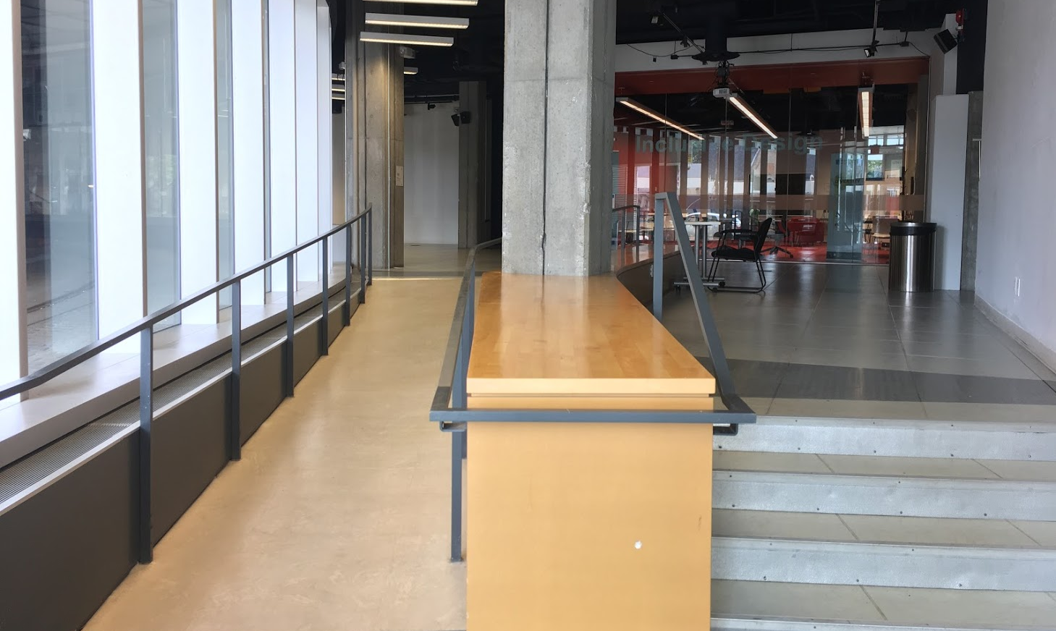
Image Description: Foyer of IDRC (49 McCaul Street). Accessible ramp available on the left.

The Red Room
The Red Room is a large open space with no windows. There is a glass wall separating the room from the foyer. There are no curtains or blinds for the glass wall. Once in a while people in the room may hear an outside noise, which is related to a moving street car around the building.

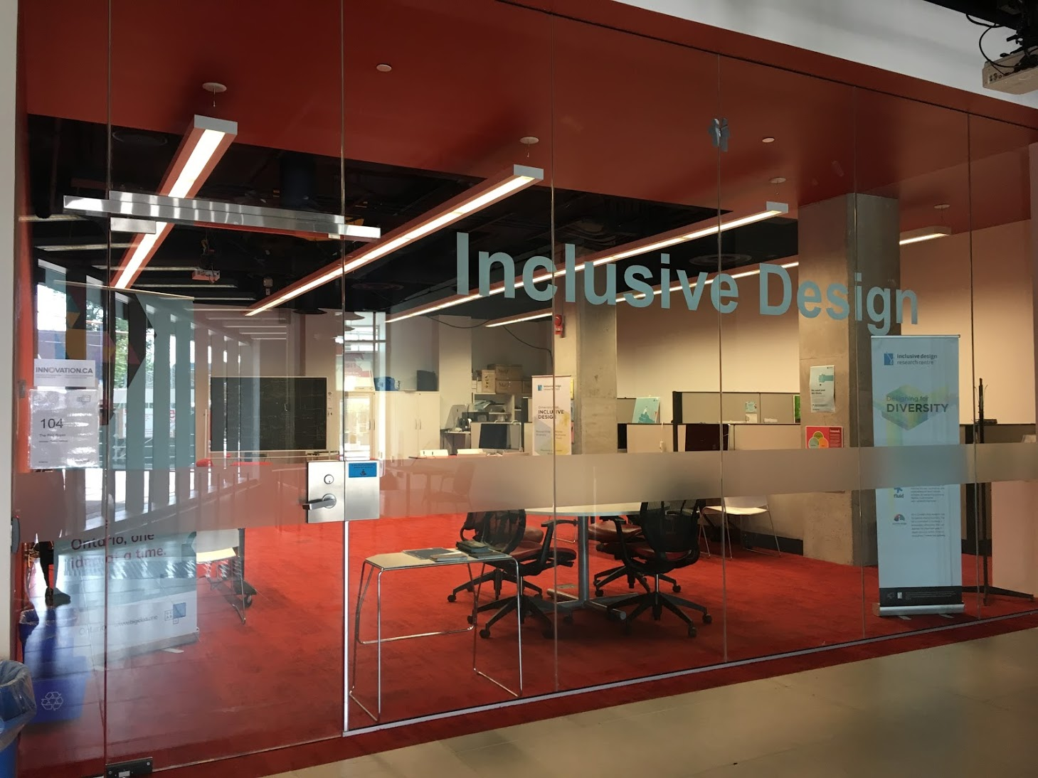
Image Description: Outside of The Red Room (room 104) at the top of the ramp.

The room’s floor is covered with red carpet. One of the large walls painted in red and the rest of the walls and the ceiling are painted white. There is some natural light brought into the room through the glass wall, however, the main source of light is artificial lighting from the ceiling. There is a mix of chairs on wheels, chairs without wheels, and arm chairs available in the room. Some of the desk are on the wheel and their height is adjustable. If you prefer specific arrangements please send us an email via [email].
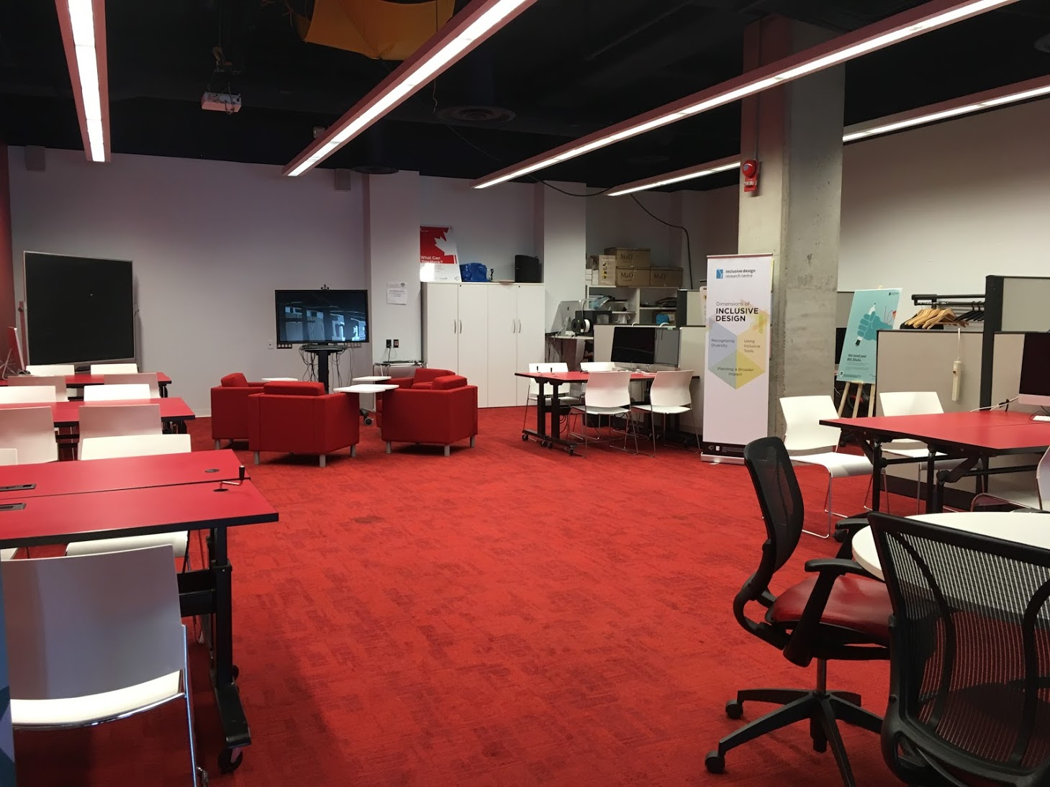Image Description: Inside The Red Room (room 104) where the co-design session will be held.

Accessible Washrooms
There is an accessible and gender neutral washroom to the left of the Red Room. The washroom is spacious with grab bars available. A urinal and toilet are available for use. Both urinal and toilet are automatic flush, but have a button above the black sensor to flush manually.
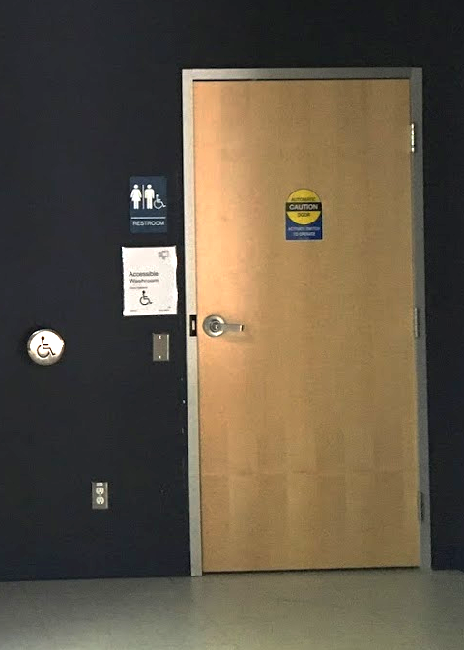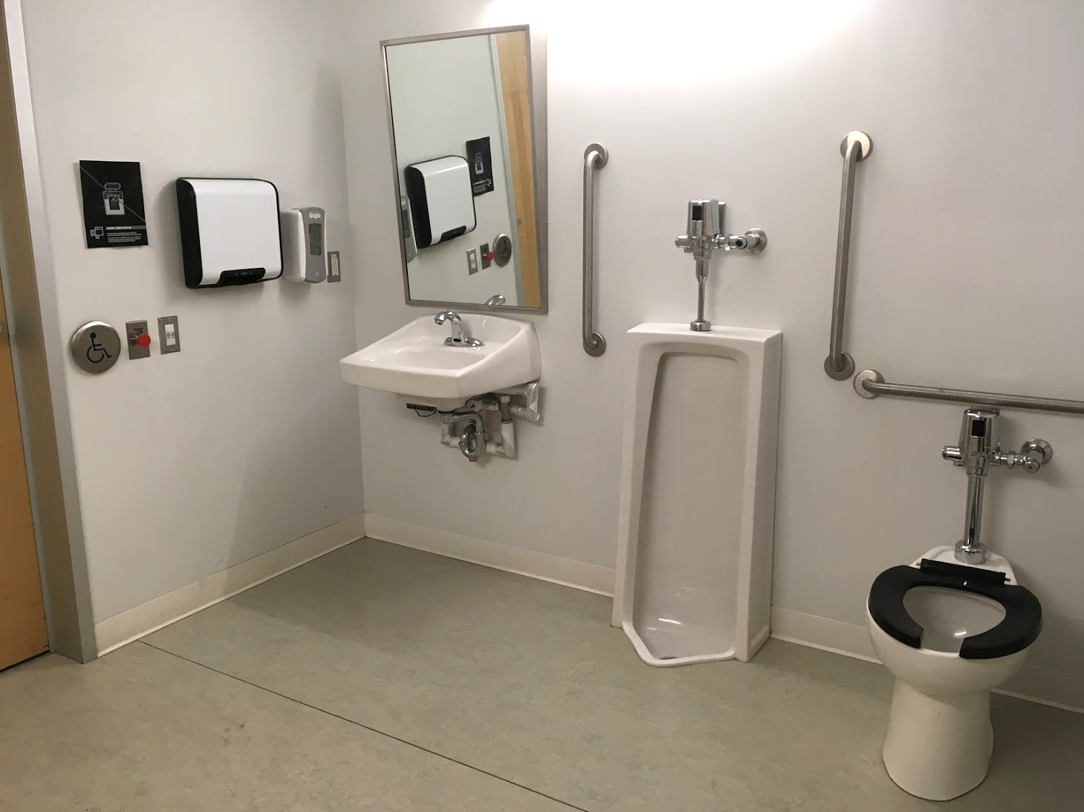
Image Description: These images show the door to the accessibility washroom and its interior.

Accessible Kitchenette
There is an accessible kitchenette to the left of the Red Room. The kitchenette offers counter space for utensils, a built-in sink with easy wheelchair access, a drying rack, a microwave, a refrigerator and a wheelchair accessible paper towel dispenser.
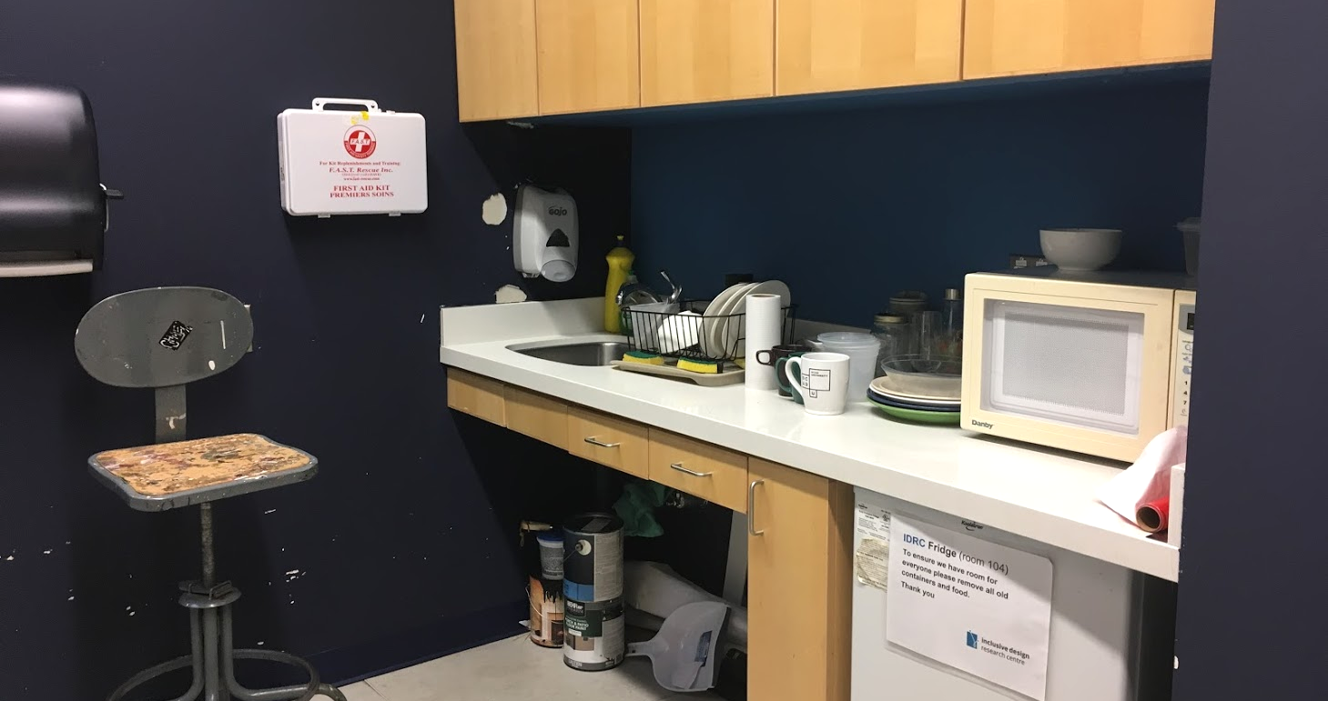
Image description: Accessible kitchenette beside The Red Room.

Making this event more inclusive
- Please help us make this space as scent free as possible. You can do this by avoiding wearing perfumes and colognes, avoiding using heavily scented body products or laundry detergents, avoiding contact with incense, cigarettes, or other things that create smoke. If you smoke, we ask that you kindly leave your coat/outer layer outside of the meeting room.
- If possible, we ask people to be mindful about visually describing anything that is being presented to the group. This is an interesting exercise as well as it gets us into a practice of inclusive communication by acknowledging that not everyone interprets things visually.
- We remind our participants to be mindful of how people prefer to identify themselves, use considerate language when addressing people with disabilities and adopt a moderate pace when speaking.
- We request that all participants forewarn the group before sharing experiences relating to disturbing or violent themes.

If you require further details and information about accessibility of this event, please send us an email via [email address]

We truly value your time and contributions and we thank you for choosing to participate in this event. We hope you enjoy this experience. If you have any further questions please contact [contact person] at [email address].

